Thoughts from your President, Maxine Paul
What a super time I’m having visiting your branches for my “Summer of Hope” challenge. Thank you all for making me so welcome. I have now called at 31 churches out of a possible 48 and I shall continue on my travels throughout August. Catch up with the photos on Facebook.

The Essex countryside is stunning and the variety of places I’ve been is amazing from inner city Leyton to the winding lanes of Great Totham with the London suburbia of Woodford in between and beyond to the seaside parishes of Clacton and Leigh-on-Sea, the sailor’s church on the quay at Maldon and Mersea Island where you can be cut off by the tide and have to linger a couple of hours longer than planned. (We did get the timings right, though!). I even got to have lunch with Anna Firth, MP for Southend West! A great mix of four cities, towns, villages and seaside – God’s diversity is so good to enjoy.

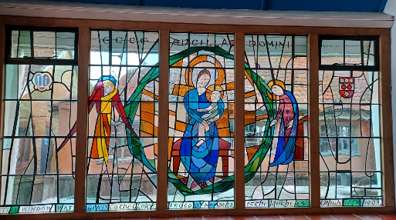
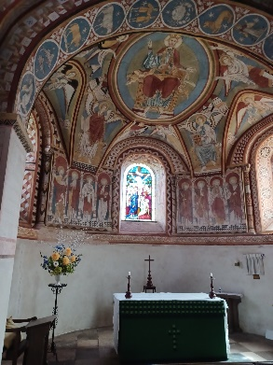
There are two churches though that stand out – totally different, but both so lovely and a complete surprise… If you want a cultural day out down narrow country lanes, head for Copford and the parish of St Michael’s and All Angels; an absolute hidden gem of a church with the oldest church wall and ceiling paintings in the whole country – a breathtaking, wow thank you God experience almost comparable to some of the great Italian churches. Then there was St Barnabas, Hadleigh. 60’s buildings don’t normally do it for me, but maybe it was because it was so light and airy – full of the Holy Spirit or maybe it was the MU stained-glass window of the Blessed Virgin Mary that set me on fire.

I am so looking forward to the Mary Sumner Day Members’ Event at Witham to celebrate the founder of this wonderful movement of Mothers’ Union and pray that many of you will join me and VP Janet to celebrate.

All this day, O Lord,
let me touch as many lives as possible for thee;
and every life I touch, do thou by thy spirit quicken,
whether through the word I speak, the prayer I breathe, or the life I live. Amen

May God continue to make this a “Summer of Hope”
Maxine x

Mary Sumner Day – Wednesday 9th August
On Mary Sumner Day we will be holding a Members’ event at St Nicholas Church, Witham between 10:30am and 2pm, service to start at 11am. Drinks will be provided, but please bring your own lunch. St Nicholas church is an easy 5min walk from Witham Station. A Mary Sumner Day service is also being held at Emmanuel Church Billericay, with coffee from 10:45am and the service at 11:30 followed by a bring and share lunch.
If your branch is looking at holding its own service, we will be circulating a Mary Sumner Day service and talk to all branch leaders and contacts.

Summer of Hope
There’s still time to fundraise for the Summer of Hope – do let us know what you have planned. If you would like to sponsor Maxine contact treasurer@muchelmsford.org.uk or you can donate via https://www.justgiving.com/page/maxine-paul-1687445214184

Database updates
Please let the diocesan secretary know if you have any member changes for the database (secretary@muchelmsford.org.uk). The next deadline for updating the central database is 25th August for the Autumn edition of Connected.

Diocesan fundraising concert: Two Lads and a Laptop
Don’t forget to order your ticket for our diocesan fundraising concert at Emmanuel Church, Billericay on 7th October in aid of English for Women. Tickets can be ordered online at Live at Emmanuel: Two Lads and a Laptop! – revPACman or in person from our diocesan treasurer Tricia McCarthy, VP Merrill Knight, or secretary Kathryn Booth. Tickets are priced at £15 (plus £1 platform fee for online orders).
Consultation on new diocesan constitution
At May Council Maxine spoke about current work to update the diocesan constitution. The new draft constitution will be circulated to all branches in late August and members will be able to submit questions and comments up till 1st October.

Clewer Initiative
The Clewer Initiative are now issuing a bi-monthly email to keep members updated on their latest projects and resources as well as sharing prayer points. To sign up to receive this visit: The Clewer Initiative (list-manage.com). Clewer have a range of resources available on their website, including resources for schools on county lines, a new resource for Food Banks, and a resource to reach out to Ukrainian refugees and those who work with them. They also run a range of training sessions and courses. To find out more visit https://theclewerinitiative.org/training-and-events

News from Mary Sumner House
For regular updates on central MU work, sign up to the central e-newsletter available on the following link: https://mothersuniononline.org/p/1I8Y-G0K/sign-up-to-the-mothers-union-mailing-list

The annual gathering in York takes place on Friday 22nd September. Please go to https://www.mothersunion.org/annual-gathering-2023 for more information and to book tickets. Please let us know if you are planning to attend.

Please note, Midday Prayers are now no longer available on the Daily Hope line but continue to be posted daily on the central Mothers’ Union Facebook page.

Dates for the dairy

- Mary Sumner Day 9th August
- Annual gathering: Friday 22nd September
- Two Lads and a Laptop concert: 7th October 7pm, Emmanuel Church, Billericay.
- AGM and Council: 13th November, Chelmsford Cathedral

